**Power BI Assignment 5**

1. **Explain DAX**

DAX stands for Data Analysis Expression is a formula Expression used in Analysis Service, Power Bi, and PowerPivot in Excel. The Data Analysis Expression contains functions, operators, and values to perform calculation and queries on data in related tables and column in tabular data models. The DAX is used in measures, calculated columns, calculated tables, and row-level security. DAX is important tool for analyst as it enables you to perform data modelling, data analysis, and use the results in decision making

Example: Total Amount = [Sales Quantity] *[Sales Each price]

Here the value for each row is calculated by doing product of value taking from sales table quantity column and sales tables Each price column to find total Amount.

1. **Explain datasets, reports, and dashboards and how they relate to each other?**

* **Dataset:** The dataset is nothing but the raw data that is imported from various data sources in Power Bi. The dataset is basically a collection of raw data which is transformed and prepare to run some analysis on it se one can draw some conclusion and meaningful insights from it. The dataset can be of various types that are Tables, links, Trees, Networks etc.
* **Report:** The reports is collection of pages that contains multiple tiles depicting some values, graphs in form of visualization which is interactive and can be better understood. The dataset (raw data) is transformed and prepared to visualize and draw some conclusion/insights in form of reports. The data is summarized in reports and better used convey the performance of business. If streaming data is supplied, dynamic changes are reflected in Visualization in reports. The user can publish their respective reports online that can be accessed by business stakeholder, organization and other users using Power Bi.
* **Dashboard:** The Dashboard is also a form of a report. The Dashboard summarize multiple reports. It can contain same element as report have. But multiple key information is alone added to dashboard from multiple reports.

When we talk how three of them dataset, report, dashboard is related, it’s a hierarchical relation first of all the dataset is made by collecting the data from various data sources then the raw data in dataset is transformed and prepared for visualizing, so we can prepare report and at last from multiple reports a dashboard is prepared that summarized multiple reports.

1. **How reports can be created in power BI, explain two ways with Navigation of each.**

The report is created in Power Bi in two ways:

1. First is selecting the type of visualization fist then the respective fields from dataset
2. Second is selecting the fields first then selecting appropriate type to visualization to visualize it

The three primary section on homepage of Power Bi desktop that user interact with are:

* **Canvas:** The canvas is the blank space that appear in middle of homepage when user open the Power Bi Desktop, user work on the canvas or we can say canvas is just a page of a report.
* **Fields Pane:** The Fields pane is present at right end of homepage where the user can the dataset loaded in power bi that contain raw data. The user can access different table and their respective columns using field pane. The field also different measures created by users.
* **Visualization Pane:** Various charts, graph, table, maps and other type of visuals can be selected form visualization pane. The visual editing and formatting can be done through visualization pane only.

**Method: 1**

* First select the type of visual you want to create. An empty tile will appear in the canvas area.
* Click and drag the column, measure or values from field pane and drop in the visualization pane (Respective x and y axis as well as legend field)
* For customization of visual use formatting option available in visualization pane

**Method: 2**

* Select the columns from field pane that to be visualize.
* When selecting them, a visual suitable for following column will appear in the canvas area.
* Drag and position them properly. Use formatting options available in visualization pane for customizing the visual.
* The type of visual can be changed just by selecting the chart tile on canvas and click the required type of graph in Visualization Pane.

1. **How to connect to data in Power BI? How to use the content pack to connect to google analytics? Mention the steps.**

Using Content Pack to Connect to Google Analytics

In Power BI, it’s straightforward to connect to the Google Analytics content pack.

* In the left navigation pane, click Get Data.



* In the Services box, click Get.

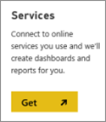

* From the menu of online services, select Google Analytics, and then click Connect

.

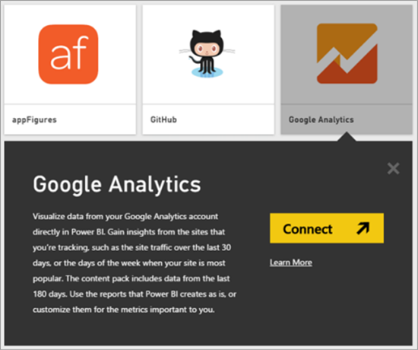

* Enter the Google Analytics account, property, and view that you want to connect to. Then sign in with your Google Analytics credentials.

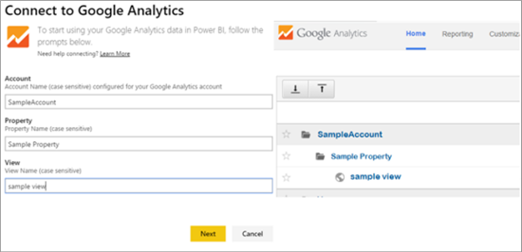

* To permit Power BI to connect to Google Analytics, click Accept.

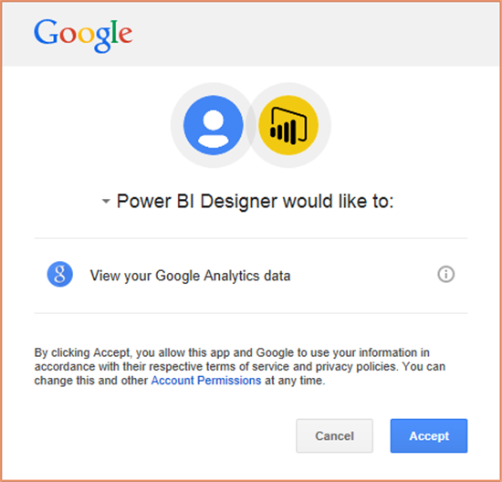

* When the import process completes, you will see a new dashboard, report, and model in the Navigation Pane. Select the dashboard to view your imported data.

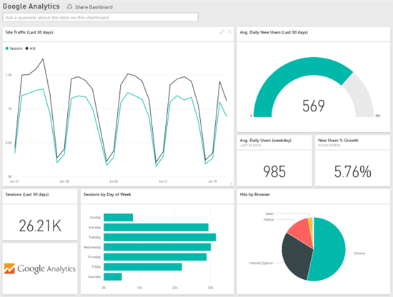

1. **How to import Local files in Power BI? Mention the Steps.**

* First on home tab click on get data, select the local file available such as excel workbook, csv file etc

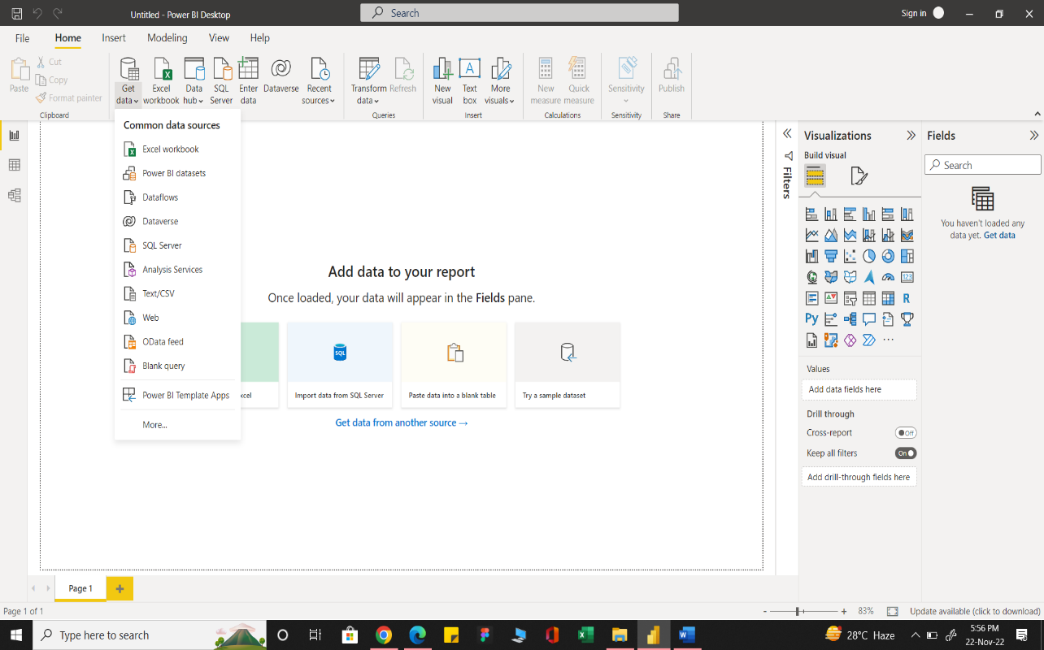

* If not available click on more option and search for the file available in local disk.

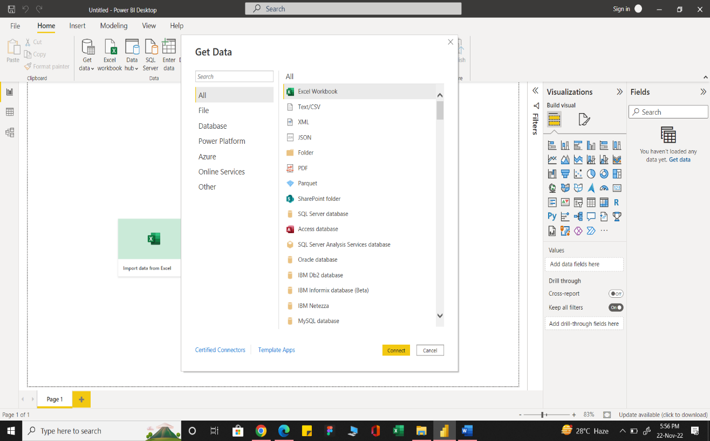

* Once you select the type of file click on the connect option, window open allowing you to select the file where it is available.

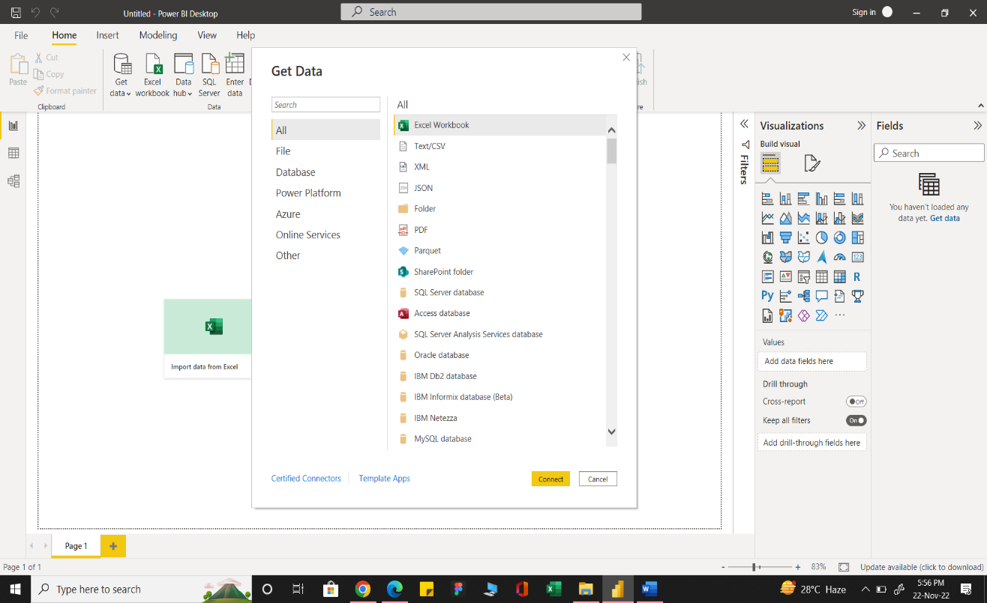

* Select the file and click open.
* If it is Excel/CSV file you have to select the sheet and then click the load button and the data will be imported.

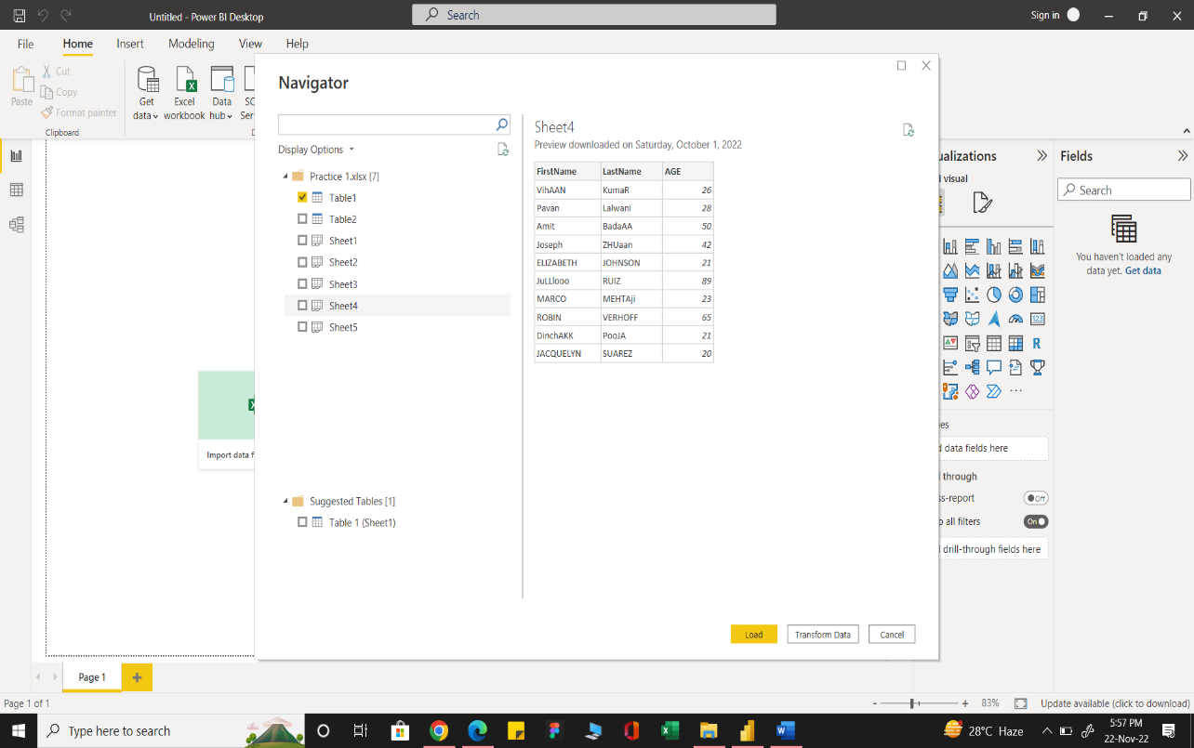

1. **In Power BI visualization, what are Reading View and Editing view?**

There are two modes of interacting with the visuals in reports

* Reading mode
* Editing mode

In Reading mode user can only interact with visuals but can make any changes. Clients in workspace are restricted to reading mode. But still user can view the visuals changing dynamically, monitor the performance, identify trends/pattern, get insights, query the report.

In Editing mode, the user can make some changes in the report. The permission for formatting and editing the report is granted. Editing mode is usually used by the users who develop the report for example analyst, report designer who collect data and create data. Only they can add or delete tiles or visualizations from the reports.